Glossaire

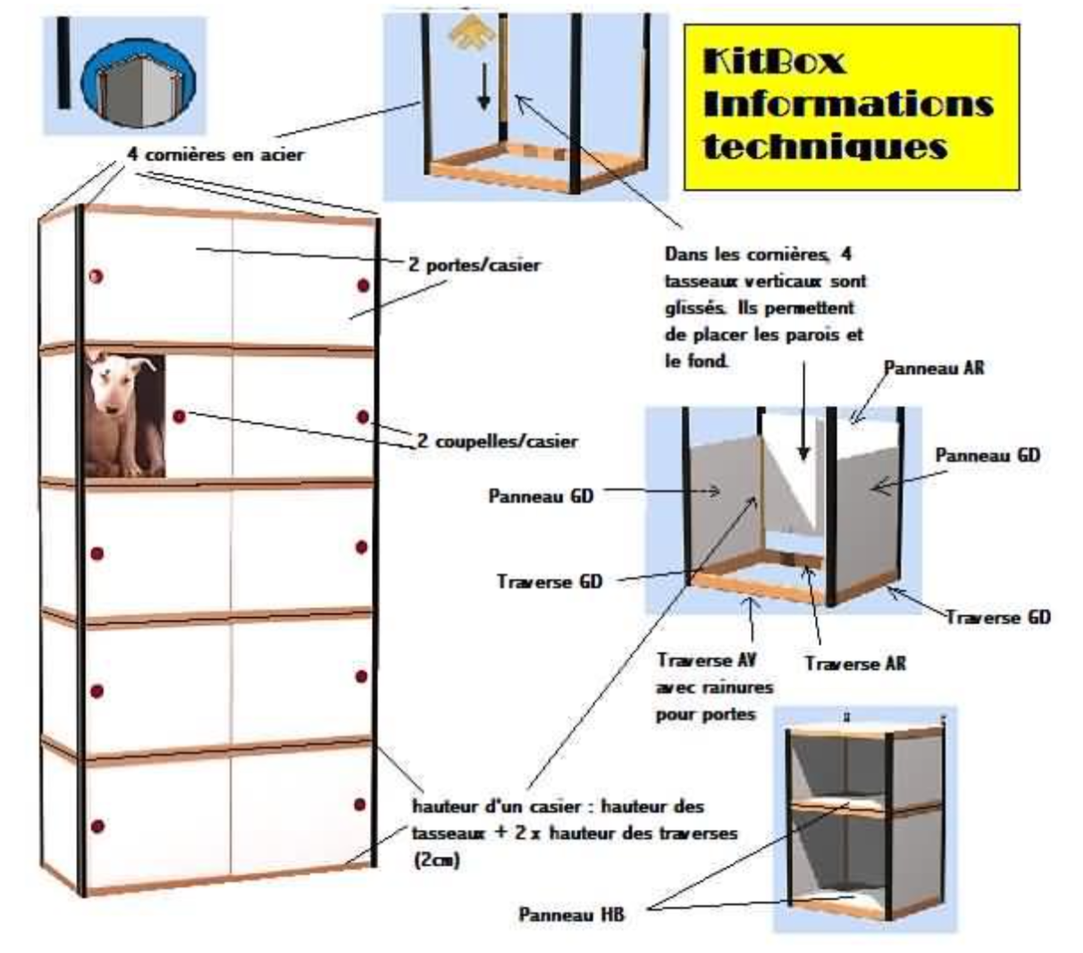

Front rail with grooves for the doors

Back Rail

Back Panel

LR Rails

Top/Low Panel Panel

LR Panel

LR Panel

2 handles/lockers

2 doors/lockers

4 support angles

LR Rails

Tasseaux verticaux 🡺 vertical cleats

Traverses 🡺 Rails

Client 🡺 Customer

Catalogue 🡺 Catalog

Armoires 🡺 Cabinet

Magasinier 🡺 Storekeeper

Casiers 🡺 Lockers

Dimensions 🡺 Dimensions